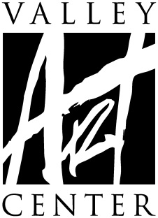
Juried Gallery Exhibit Contract
Comix
September 13–October 16, 2019

This fall, Valley Art Center presents an exhibit focusing on comics (Ka-PLOW!). In conjunction with Cleveland-area comic artists Gary and Laura Dumm, this exhibit will combine educational material with original pieces by local, regional, and national comic artists (ZING!). This exhibit (POW!) will feature an open entry segment to be juried by the Dumm’s, as well as select pieces curated by the Dumm’s to spotlight specific moments or movements in comic history with a focus on Ohio’s contributions to this fascinating medium.
Curated by, Gary and Laura Dumm
IMPORTANT DATES
Notification of acceptance
on VAC website By 4 p.m., Tuesday, June 4, 2019
Please do not call our office
Artwork delivery Thursday, August 29, 2019, 4pm - 6pm
Friday, August 30, 2019, 8am - 10am
Saturday, August 31, 2019, 10am - 2pm
Pick up of exhibited art Thursday, October 17, 2019, 4pm - 6pm
Friday, October 18, 2019, 8am - 10am
Saturday, October 19, 2019, 10am - 2pm
Artists are encouraged to attend:
- Opening Night Reception–Friday, September 13, 2019 - 6 to 8 p.m.

Comix
Entry Procedure and Eligibility
- Entry fee: $10, up to 3 pieces per artist.
No Refunds. Payment of entry fee does not guarantee acceptance.
- Juried and Curated by Gary and Laura Dumm
- Deliver your art, and entry paperwork on Thursday, August 29, 4–6 p.m.; Friday, August 30, 8–10 a.m.; or Saturday, August 31, 10 a.m.–2 p.m.
- Art that has been previously displayed at Valley Art Center is not eligible. Accepted work, if exhibited, will not be eligible to enter future VAC exhibits.
- All artwork must be properly finished and ready for exhibit
(all 2D work MUST be wired for hanging—NO SAW TOOTH HANGERS)
*2D artwork not properly wired will not be accepted.
**Please review framing guide at www.valleyartcenter.org
- All work must be original and created by the entering artist. Accepted media include: oils, acrylics, watercolor, drawing, printmaking, photography, mixed media, collage, textiles, jewelry, glass, sculpture, ceramics, enamel, and metalwork. Giclee (inkjet), toner or lithographic reproductions of original artwork are not permitted, except in the specific cases of fine art prints (printmaking) and/or digital photography. Commercial fabrication, casting or editioning in mixed media and sculpture should be produced in keeping with fine art standards.
- VAC reserves the right to refuse any artwork deemed unacceptable based on presentation and/or content or lack of relevance to the theme or pieces valued above $20,000.
- 2D work that is more than 4 feet by 4 feet and 3D work that is larger than 3 feet square may be limited by VAC staff.
- Every precaution is taken in handling piece(s) during installation and the exhibition. While on VAC premises, insurance is carried for fire, burglary and theft and is liable to the exhibitor only to the extent of its recovery under said policies. VAC reserves the right to refuse any artwork deemed “too delicate” to adequately protect during normal handling by VAC staff. Artist MUST sign a waiver assuming ALL responsibility of said artwork during installation, exhibition and dismantling of exhibit. VAC will only cover artwork should any of the above stated situations occur while artwork is on exhibit. Valley Art Center encourages all artists to carry insurance on their own artwork.
- Artist shall be responsible for costs of delivery and insurance of the exhibited works during transport to and from VAC. Include a prepaid return shipping label inside the package when shipping art, or mail one before the last week of the exhibit.
- Artist agrees to work being displayed throughout exhibition dates. Artwork may not be removed earlier than Wednesday, October 16, 2019 at 4 p.m. VAC shall have the right to show and use the items exhibited, for the purpose of sale to its customers.
- Once in VAC possession for an exhibit, and through the entire duration of the exhibit, all sales of artists’ work generated by any means—including but not limited to artists’ self-promotion or social media posts—are under the umbrella of this contract based on the reasonable assumption that artist is promoting the specific piece or pieces at that particular time due to said piece or pieces being included in VAC’s exhibit.
- VAC keeps 40% commission on the selling price of all artwork (unless NFS). VAC shall pay the agreed amount (60% of marked price) to the exhibitor by November 15, 2019 (30 days following the end of the show on October 16, 2019).
- Each piece must be clearly labeled with TWO entry tags per piece. For curating and jurying purposes, the tags should be separated and attached carefully, on the back as well as folded over to the front of 2D work and on the bottom as well as folded over to the front/top of 3D work.
- VAC does not have adequate storage space to hold work after designated pick-up dates and times. Please note VAC will grant a grace period of 5 business days, after which artists will be charged a storage fee of $5 per day which must be paid upon retrieval. If the artist knows there will be a conflict which prohibits pick-up during designated dates and times, the artist must arrange an appointment with the gallery manager for the artist or artist’s named representative to ensure pick-up before the end of the grace period.
- Participation in this exhibition implies agreement to the stated conditions of the
exhibition including permission to photograph displayed work for documentation and publicity purposes.
- All artists are invited to the Opening Night Reception—Friday, September 13, 2019 from 6-8pm.
- Donations of savory or sweet finger foods are graciously accepted to keep gallery costs down.
- These terms may only be changed by written amendment signed by VAC.
Comix — Artist Contract
Please complete all fields and return to Valley Art Center when dropping off artwork.
Name Phone
first
last
Address
City/State/Zip
Email
VAC Student? Yes No
–May we give contact information to the press if requested? Yes___ No___
–FRAGILE ARTWORK WAIVER (if applicable, include with contract) Yes___ No___
This includes FRAGILE and/or any ARTWORK NEEDING SPECIAL or SPECIFIC
HANDLING INSTRUCTIONS. Artist has the right to withdraw any artwork for
consideration once reviewing the terms of the waiver.
I AGREE TO THE AFOREMENTIONED CONDITIONS OF THIS EXHIBIT:
Artist Signature Date
(Guardian Signature if the artist is under the age of 18 years)
*Please fill out all fields below for each artwork. Title exactly as you’d like it written. For medium indicate as follows, for example: Oil pastel on board or Silver gelatin print or Porcelain with glaze.

Title
Medium
Price/NFS If NFS, Replacement Value_______________________
Title
Medium
Price/NFS If NFS, Replacement Value_______________________
Title
Medium
Price/NFS If NFS, Replacement Value_______________________

Social Media
Valley Art Center is committed to maximizing the visibility of our exhibits, and the artists who participate. To that end, we regularly post images of work from our exhibits on various social media platforms including, but not limited to; Facebook, Instagram, and Twitter. We believe that it is useful and beneficial to our exhibiting artists and can be more so if we are able to tag the artists in the posts of their work so that our followers can explore and interact with our artists to a greater degree. If you would like, please include your various social media links or addresses below. This is entirely voluntary and participating or not will have no effect on your inclusion in this exhibit.
Finally, as we frequently have more pieces in an exhibit than we have days that it is open, we cannot guarantee that any specific piece will be included in the social media posts. Including your information does not guarantee that your piece(s) will be included in our posts.

Facebook:

Instagram:

Twitter:

Other:

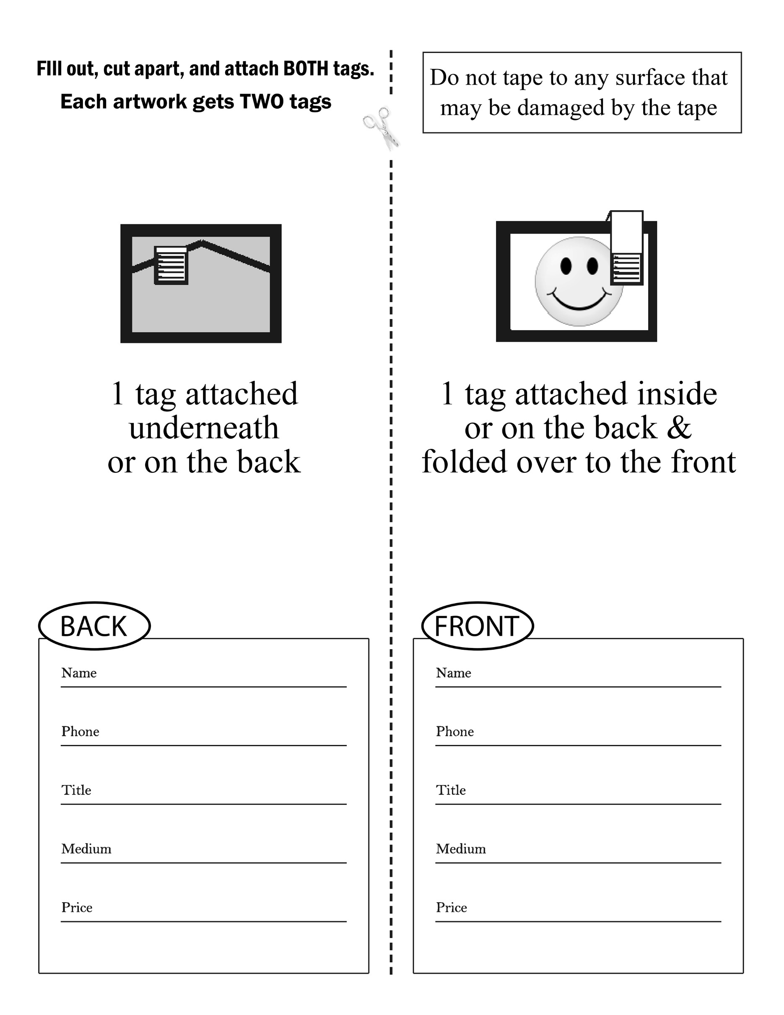

FRAGILE ARTWORK WAIVER
(** COMPLETE IF ARTWORK IS FRAGILE**)

Valley Art Center (VAC) reserves the right to refuse any artwork deemed “too fragile” to adequately protect during normal handling by VAC staff and volunteers. Artist MUST sign a waiver holding VAC harmless for any damage the piece may incur while on VAC premises.

I, ______________________________________________________________, would like to submit my artwork,
(artist name)

(title of artwork
constructed using
(materials used in piece)
valued at for
(value of piece) (gallery exhibit)

I acknowledge that the above listed artwork has been deemed “fragile.”

(artist signature) (date)

(artist–print name)

(contact phone number) (email)

(address) (city) (zip)

(VAC staff signature) (date)

(VAC staff name)

