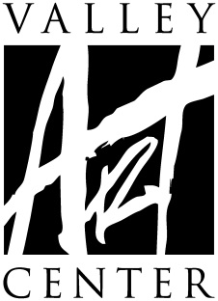
Gallery Exhibit Contract

Formed From Flame | Clay - Metal - Glass
June 26, 2020 – August 5, 2020

For tens of thousands of years we have harnessed the power of fire to harden clay, soften metal and change the very state of sand in order to create objects of both useful function and incredible beauty. It can be argued that these techniques and objects have been critical in the development of human society. In celebration of this history, Valley Art Center is excited to invite artists working in clay, metal, and glass to an exhibit of functional pieces to be on display Summer of 2020.
3D artists from the Chagrin Valley to around the world are invited to submit their work in Clay, Glass, and Metal. Artists may submit up to three pieces for this exhibit. Functional work will be prioritized during jurying.
Juror/Curator—Mary Urbas
IMPORTANT DATES
Artwork delivery Friday, June 12, 2020 – by appointment
Saturday, June 13, 2020 – by appointment
Notification of acceptance
on VAC website By 5 p.m., Tuesday, June 9, 2020
valleyartcenter.org/accepted.html
Please do not call our office
Pick up of exhibited art Friday, August 7, 2020
Saturday, August 8, 2020
Formed From Flame
Entry Procedure and Eligibility
- Juror/Curator – Mary Urbas
- Deliver your art and entry paperwork on Friday, June 12, 2020, or Saturday, June 13, 2020, at the appointment time given to you.
- Art that has been previously displayed at Valley Art Center is not eligible.
- All artwork must be properly finished and ready for exhibit
(all 2D or wall-hangable work MUST be wired for hanging—NO SAW TOOTH HANGERS)
*2D artwork not properly wired will not be accepted.
**Please review framing guide at www.valleyartcenter.org
- All work must be original and completed by entering artist.
- Valley Art Center (VAC) reserves the right to refuse any artwork deemed unacceptable based on presentation and/or content or lack of relevance to the theme or pieces valued above $20,000.
- 2D work that is more than 4 feet by 4 feet and 3D work that is larger than 3 feet square may be limited by VAC staff.
- Every precaution is taken in handling piece(s) during installation and the exhibition. While on VAC premises, insurance is carried for fire, burglary and theft and is liable to the exhibitor only to the extent of its recovery under said policies. VAC reserves the right to refuse any artwork deemed “too delicate” to adequately protect during normal handling by VAC staff. Artist MUST sign a waiver assuming ALL responsibility of said artwork during installation, exhibition and dismantling of exhibit. VAC will only cover artwork should any of the above stated situations occur while artwork is on exhibit. Valley Art Center encourages all artists to carry insurance on their own artwork.
- Artist shall be responsible for costs of delivery and insurance of the exhibited works during transport to and from VAC.
- Artist agrees to work being displayed throughout exhibition dates. Artwork may not be removed earlier than August 5, 2020 at 4 p.m. VAC shall have the right to show and use the items exhibited for the purpose of sale to its customers unless pieces are marked NFS (not for sale) by the artist.
- Once in VAC possession for an exhibit, and through the entire duration of the exhibit, all sales of artists’ work generated by any means – including but not limited to artists’ self-promotion or social media posts - are under the umbrella of this contract based on the reasonable assumption that artist is promoting the specific piece or pieces at that particular time due to said piece, or pieces being included in VAC’s exhibit
- VAC keeps 40% commission on the selling price of all artwork. VAC shall pay the agreed amount (60% of marked price) to the exhibitor by September 4, 2020 (30 days following the end of the show on August 5, 2020).
- Each piece must be clearly labeled with Artist’s Name, Title, Cost, and media information. For curating and jurying purposes, the tags should be separated and attached carefully, on the back as well as folded over to the front of 2D work and on the bottom as well as folded over to the front/top of 3D work.

- VAC does not have adequate storage space to hold work after designated pick-up dates and times. Please note VAC will grant a grace period of 5 business days, after which artists will be charged a storage fee of $5 per day which must be paid upon retrieval. If the artist knows there will be a conflict which prohibits pick-up during designated dates and times, the artist must arrange an appointment with the gallery manager for the artist or artist’s named representative to ensure pick-up before the end of the grace period.
- Participation in this exhibition implies agreement to the stated conditions of the
exhibition including permission to photograph displayed work for documentation and publicity purposes.
- These terms may only be changed by written amendment signed by VAC.

Formed From Flame — Artist Contract
Please complete all fields and return to Valley Art Center when dropping off artwork.

Name Phone
Address
City/State/Zip
Email
VAC Student? Yes No –May we give contact information to the press if requested? Yes___ No___
–FRAGILE ARTWORK WAIVER (if applicable, include with contract) Yes___ No___
This includes FRAGILE and/or any ARTWORK NEEDING SPECIAL or SPECIFIC
HANDLING INSTRUCTIONS. Artist has the right to withdraw any artwork for
consideration once reviewing the terms of the waiver.
I AGREE TO THE AFOREMENTIONED CONDITIONS OF THIS EXHIBIT:
Artist Signature Date
(Guardian Signature if the artist is under the age of 18 years)
*Please fill out all fields below for each artwork. Title exactly as you’d like it written. For medium indicate as follows, for example: Oil pastel on board or Silver gelatin print or Porcelain with glaze.

Title
Medium

Price/NFS If NFS, Replacement Value

Title
Medium

Price/NFS If NFS, Replacement Value

Social Media
Valley Art Center is committed to maximizing the visibility of our exhibits, and the artists who participate. To that end, we regularly post images of work from our exhibits on various social media platforms including, but not limited to; Facebook, Instagram, and Twitter. We believe that it is useful and beneficial to our exhibiting artists and can be more so if we are able to tag the artists in the posts of their work so that our followers can explore and interact with our artists to a greater degree. If you would like, please include your various social media links below. This is entirely voluntary and participating or not will have no effect on your inclusion in this exhibit.
Finally, as we frequently have more pieces in an exhibit than we have days that it is open, we cannot guarantee that any specific piece will be included in the social media posts. Including your information does not guarantee that your piece(s) will be included in our posts.

Facebook:

Instagram:

Twitter:

Other:

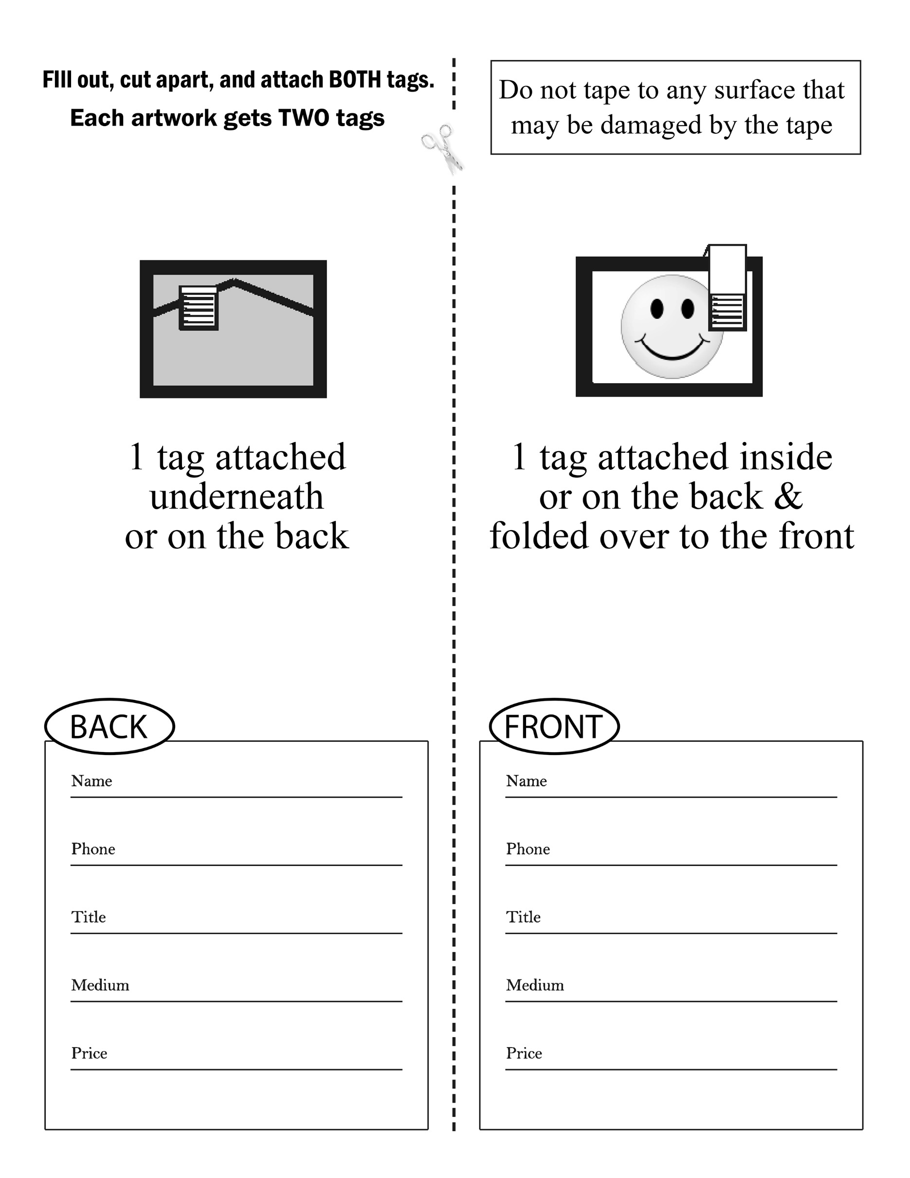

FRAGILE ARTWORK WAIVER
(** COMPLETE IF ARTWORK IS FRAGILE**)

Valley Art Center (VAC) reserves the right to refuse any artwork deemed “too fragile” to adequately protect during normal handling by VAC staff and volunteers, and through the duration of the exhibit. To exhibit any artwork at VAC deemed “fragile” by VAC Staff, Artist MUST sign a waiver holding VAC harmless for any damage the piece (or pieces) may incur while on VAC premises.

I, ______________________________________________________________, would like to submit my artwork,
(artist name)

(title of artwork
constructed using
(materials used in piece
valued at for
(value of piece) (gallery exhibit)
I acknowledge that the above listed artwork has been deemed “fragile.”

(artist signature) (date)

(artist–print name)

(contact phone number) (email)

(address) (city) (zip)

(VAC staff signature) (date)

(VAC staff name)

