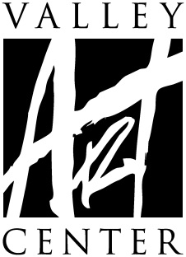
Gallery Exhibit Contract
Annual Student/Faculty Art Exhibit
January 28 through March 9, 2022

Students and instructors, it's time to start thinking about showcasing the art you have made in conjunction with classes or workshops at Valley Art Center. The Annual Student & Faculty Exhibit is a wonderful opportunity to get your art on the wall where people can appreciate your hard work and creativity! Every VAC student who has attended between June 2020 and December 2021 is invited to submit artwork that has not yet been exhibited in a show at VAC. Faculty are invited to submit any one work of art that they created in the same time period. 2D pieces must be properly framed and wired.

IMPORTANT DATES
Artwork Delivery Dates Friday, January 14, 10 a.m. – 4 p.m.
Saturday, January 15, 10 a.m.–2 p.m.
Artwork Pick Up Dates Friday, March 11, 10 a.m. – 4 p.m.
Saturday, March 12, 10 a.m.–2 p.m.
VAC does not have the resources to store art.
Daily storage fees may apply for unclaimed art.

Opening Reception: Friday, January 28, 6 – 8 p.m.

2022 Annual Student/Faculty Art Exhibit
Entry Procedure and Eligibility
- Entry fee $10. No Refunds.
- Students are invited to submit any one work of art that they created in a class or workshop at Valley Art Center (VAC) between June 2020 and December 2021. Faculty are invited to submit any one work of art that they created in the same time period.
- Deliver your art, entry fee and entry paperwork on Friday, January 14, 10 a.m. – 4 p.m.; or Saturday, January 15, 10 a.m.–2 p.m. If you are sending a friend to deliver your art, please make sure you have filled out and signed this contract and send it, and the entry fee, along with the artwork.
- Art that has been previously displayed at Valley Art Center is not eligible.
- All artwork must be properly finished and ready for exhibit
(All 2D work MUST be wired for hanging—NO SAW TOOTH HANGERS)
*2D artwork not properly wired will not be accepted.
**Please review framing guide at www.valleyartcenter.org
- Each piece must be clearly labeled with one entry tags per piece. For curating and jurying purposes, the tag should be attached to the back and then folded over to the front of 2D work. For 3D work the tag should be fully visible when the piece is set down.
- Valley Art Center reserves the right to refuse any artwork deemed unacceptable based on presentation and/or content or lack of relevance to the theme or pieces valued above $20,000.
- 2D work that is more than 4 feet by 4 feet and 3D work that is larger than 3 feet square may be limited by VAC staff.
- Every precaution is taken in handling piece(s) during installation and the exhibition. While on VAC premises, insurance is carried for fire, burglary and theft and is liable to the exhibitor only to the extent of its recovery under said policies. VAC reserves the right to refuse any artwork deemed “too delicate” to adequately protect during normal handling by VAC staff. Artist MUST sign a waiver assuming ALL responsibility of said artwork during installation, exhibition and dismantling of exhibit. VAC will only cover artwork should any of the above stated situations occur while artwork is on exhibit. Valley Art Center encourages all artists to carry insurance on their own artwork.
- Artist shall be responsible for costs of delivery and insurance of the exhibited works during transport to and from VAC.
- Artist agrees to work being displayed throughout exhibition dates. Artwork may not be removed earlier than March 9, 2021 at 4pm. VAC shall have the right to show and use the items exhibited for the purpose of sale to its customers.
- If you are sending a friend to pick up your art, you must inform the Gallery Manager at by emailing to gallery@valleyartcenter.org before the close of the exhibit on Wednesday, March 9, 2021. VAC will not release art to anyone except the creating artist without previous arrangements being made in writing.
- VAC keeps 40% commission on the selling price of all artwork (unless NFS). VAC shall pay the agreed amount (60% of marked price) to the exhibitor by Friday, April 8, 2022 (30 days following the end of the show on March 9, 2022). Any piece marked NFS must still have a declared value for insurance purposes.
- VAC does not have adequate storage space to hold work after designated pick-up dates and times. Please note VAC will grant a grace period of 5 business days, after which artists will be charged a storage fee of $5 per day which must be paid upon retrieval. If the artist knows there will be a conflict which prohibits pick-up during designated dates and times, the artist must arrange an appointment with the gallery manager for the artist or artist’s named representative to ensure pick-up before the end of the grace period.
- Participation in this exhibition implies agreement to the stated conditions of the exhibition including permission to photograph displayed work for documentation and publicity purposes.
- These terms may only be changed by written amendment signed by VAC.

2022 Annual Student/Faculty Art Exhibit — Artist Contract
Please complete all fields and return to Valley Art Center when dropping off accepted artwork.

Name Phone
first last
Address
City/State/Zip
Email
–May we give contact information to the press if requested? Yes___ No___
-FRAGILE ARTWORK WAIVER (if applicable, include with contract) Yes___ No___
This includes FRAGILE and/or any ARTWORK NEEDING SPECIAL or SPECIFIC
HANDLING INSTRUCTIONS. Artist has the right to withdraw any artwork for
consideration once reviewing the terms of the waiver.
I AGREE TO THE AFOREMENTIONED CONDITIONS OF THIS EXHIBIT:
Artist Signature Date
(Guardian Signature if the artist is under the age of 18 years)
*Please fill out all fields below for each artwork. Title exactly as you’d like it written. For medium indicate as follows, for example: Oil pastel on board or Silver gelatin print or Stoneware with glaze.

Please fill out all fields below for artwork to be exhibited
Title
Medium

Price/NFS If NFS, Replacement Value
Class/Session/Year
Instructor

Entry Fee, $10. CASH
CHECK: # ___________
V | MC | D | AMEX :

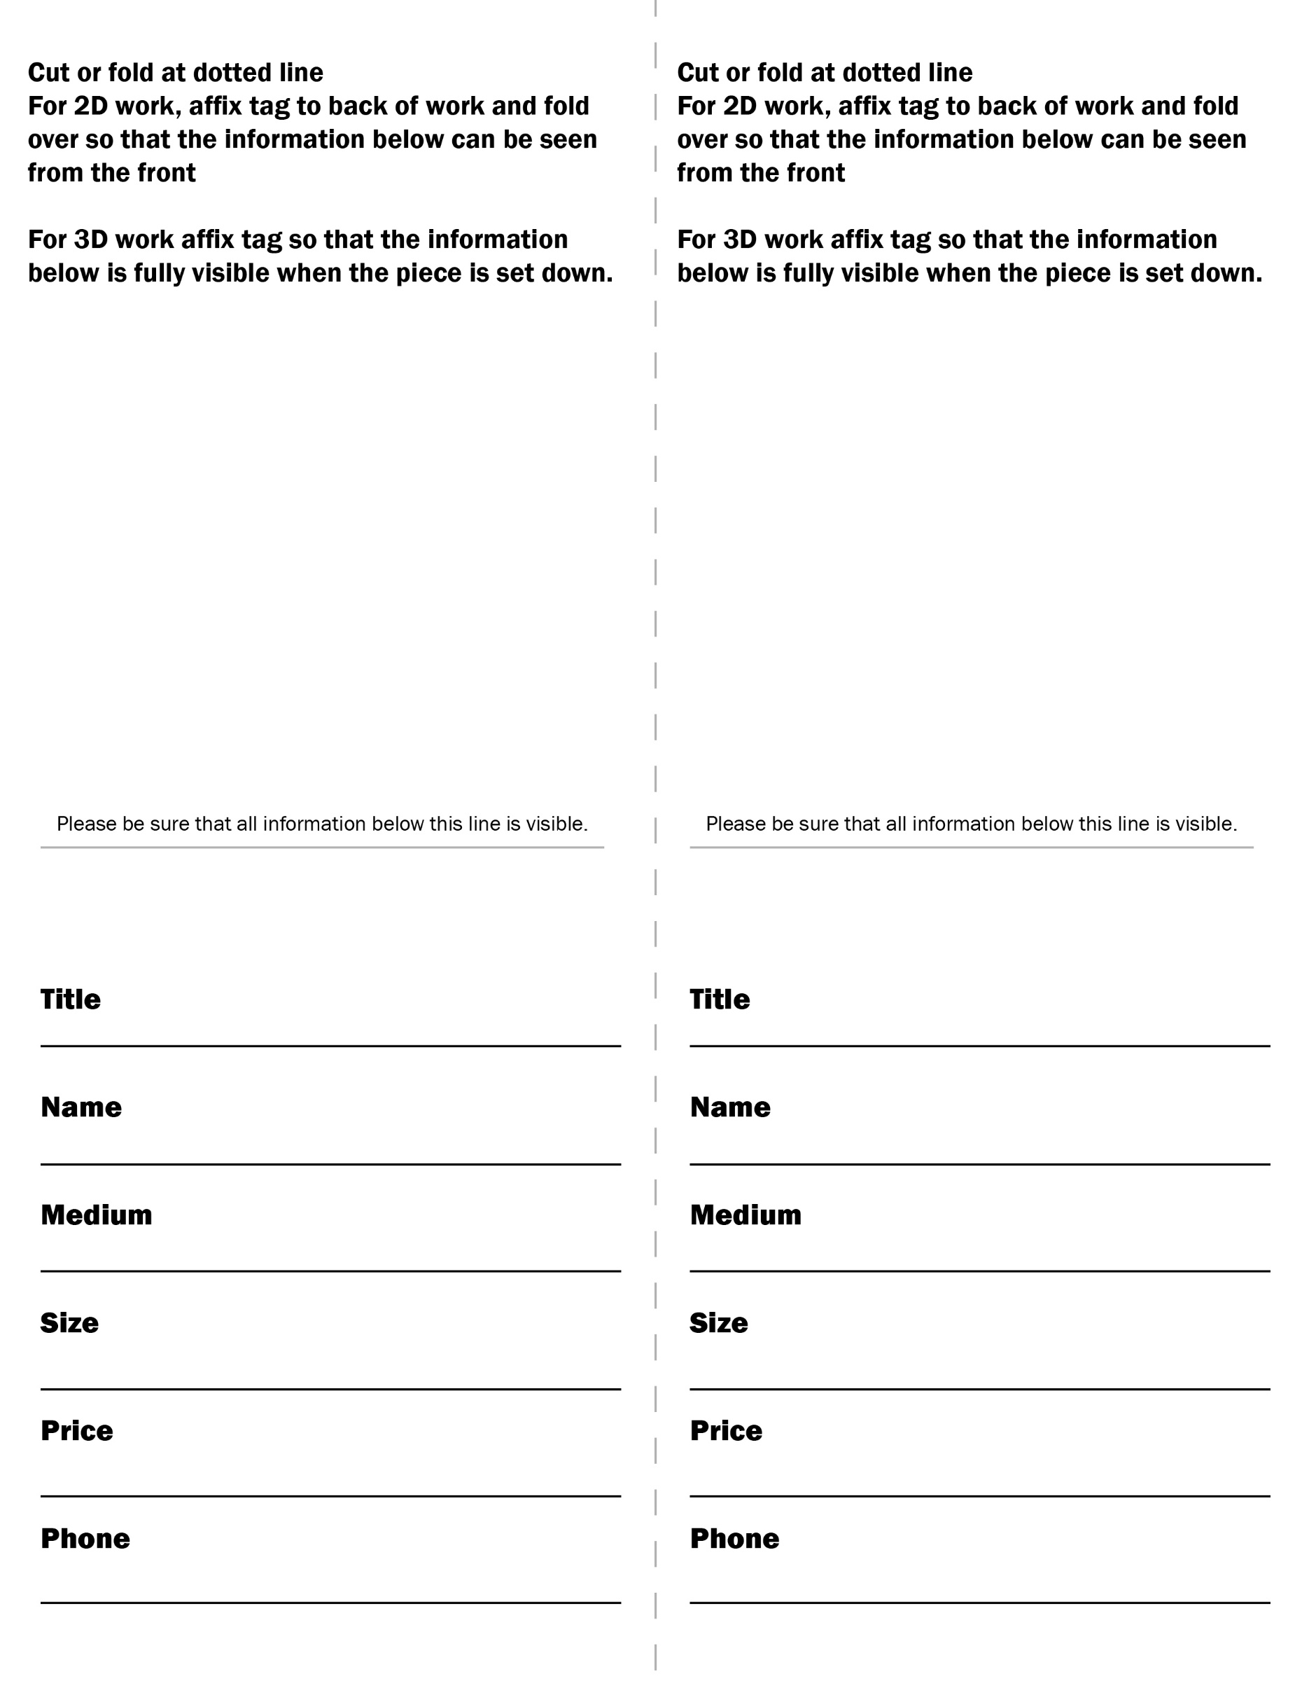

FRAGILE ARTWORK WAIVER
(** COMPLETE IF ARTWORK IS FRAGILE**)

Valley Art Center (VAC) reserves the right to refuse any artwork deemed “too fragile” to adequately protect during normal handling by VAC staff and volunteers. Artist MUST sign a waiver holding VAC harmless for any damage the piece may incur while on VAC premises.

I, _________________________________________________, would like to submit artwork deemed fragile:
(artist name)

(title of artwork
constructed using
(materials used in piece
valued at for
(value of piece) (gallery exhibit)

I acknowledge that the above listed artwork has been deemed “fragile.”

(artist signature) (date)

(artist–print name)

(contact phone number) (email)

(address) (city) (zip)

(VAC staff signature) (date)

